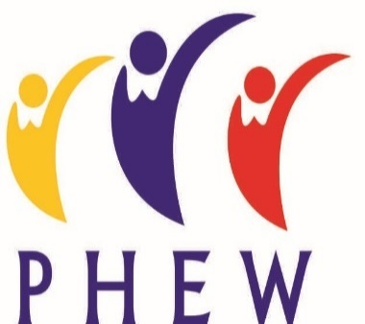
March 2020

Contingency Plans re Corona Virus (COVID-19)

Dear Guests and Carers

You will all by now be aware of the potential impact of anyone suffering from or being in contact with COVID. At PHEW it is our hope that at present we will continue to operate as usual and your bookings will not be affected, however I would ask that for the safety of everyone if you or a member of your family are suffering from or are in contact with
COVID-19 within two weeks of your booking in PHEW that you cancel the visit. When the self quarantine period is over we will try to rearrange your stay.

I apologise for any inconvenience this may cause, but as we often have guests with complex health needs staying with us, I am sure you can appreciate that we are taking these steps to ensure that everyone is protected.

Health Protection Scotland and NHS Inform have important information and guidance that is continuously updated as the situation develops. These can be found here: https://www.hps.scot.nhs.uk/a-to-z-of-topics/covid-19/ and here: https://www.nhsinform.scot/illnesses-and-conditions/infections-and-poisoning/coronavirus-covid-19.

Kind Regards

Drina Craig
Manager

